Part of SEED Project , School of Information Technology & Engineering
Vellore Instiute of Technology, Vellore
Dr. Aarthy S L, Dr. Sujatha R
School of Information Technology & Engineering
Vellore Institute of Technology,
Vellore, Tamil Nadu,
India
Abstract: This dataset consists of thermal images of diseased and healthy leaves of paddy crops (Oryza sativa).
1. Data Repository Description
1.1 Camera specification
The images are captured with the help of high-resolution cameras FLIR E8 (Thermal camera). The specification of these cameras are mentioned below, FLIR E8’s crisp 76,800 (320 X 240) pixel infrared resolution, +2% accuracy of reading for ambient temperature 10^{O}C to 35^{O} C(50^{O} to 95^{O}F) and object temperature above 0^{O}C (32^{O}F), field of view is 45^{O} X 34^{O}
1.2 Image collection
The images are collected from the state of Tamil Nadu from the following regions as follow; the Agri field (VIT School of Agricultural Innovations And Advanced Learning. (VAIAL), VIT Vellore), Brahmapuram, Sevur, Latheri, Vaduthangal from Vellore district. The complete field survey was undergone concerning disease symptoms and climatic conditions. The diseases are classified with the help of plant pathologist Dr. Priyadharshini B plant pathologist from VAIAL, Vellore Institute of Technology, Vellore.
S.NO | Diseases |  | Number of thermal images
1 | Bacteria leaf blight |  | 220
2 | Blast |  | 67
3 | Leaf spot |  | 80
4 | Leaf folder |  | 34
5 | Hispa |  | 142
6 | Healthy leaves |  | 93
 | Total |  | 636

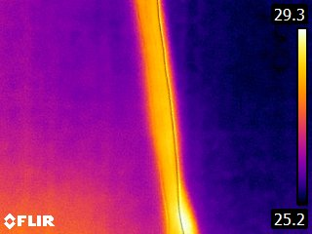  a. Bacterial leaf blight (Thermal image) | 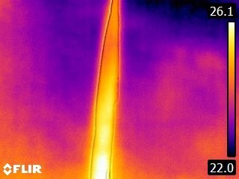  b. Hispa (Thermal image) | 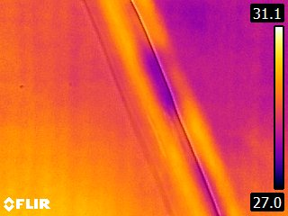  c. Blast (Thermal image)
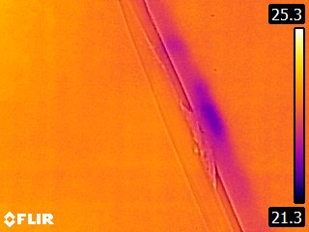  d. Leaf folder(Thermal image) | 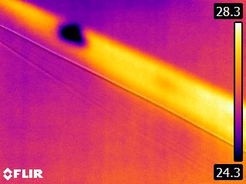  e. Leaf spot(thermal image) | 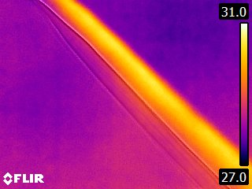  f. Healthy Leaf (Thermal image)

2. Paddy crop diseases
The diseases namely Bacterial leaf blight, blast, leaf spot, leaf holder, hispa and healthy leaves are observed in the following regions as mentioned below; Agri field (VIT School of Agricultural Innovations And Advanced Learning. (VAIAL), VIT Vellore), Brahmapuram, sevur, Latheri, vaduthangal from Vellore district. The detailed description of the kinds of diseases are discussed below.
2.1 Bacterial leaf blight
Bacterial blight is caused by Xanthomonas oryzae pv. oryzae. It causes wilting of seedlings and yellowing and drying of leaves. The disease is most likely to develop in areas that have weeds and stubbles of infected plants. It can occur in both tropical and temperate environments, particularly in irrigated and rainfed lowland areas. In general, the disease favors temperatures at 25−34°C, with relative humidity above 70%.
It is commonly observed when strong winds and continuous heavy rains occur, allowing the disease-causing bacteria to easily spread through ooze droplets on lesions of infected plants. Bacterial blight can be severe in susceptible rice varieties under high nitrogen fertilization. Check for wilting and yellowing of leaves, or wilting of seedlings (also called kresek). On seedlings, infected leaves turn grayish-green and roll-up. As the disease progresses, the leaves turn yellow to straw-colored and wilt, leading whole seedlings to dry up and die. Kresek on seedlings may sometimes be confused with early rice stem borer damage. To distinguish kresek symptoms from stem borer damage, squeeze the lower end of infected seedlings between the fingers. Kresek symptoms should show yellowish bacterial ooze coming out of the cut ends. Unlike plants infested with stem borer, rice plants with kresek are not easily pulled out from soil [1].
2.2 Blast
Blast is caused by the fungus Magnaporthe oryzae. It can affect all the above-ground parts of a rice plant: leaf, collar, node, neck, parts of panicle, and sometimes leaf sheath. Blast can occur wherever blast spores are present.
It occurs in areas with low soil moisture, frequent and prolonged periods of rain shower, and cool temperature in the daytime. In upland rice, large day-night temperature differences that cause dew formation on leaves and overall cooler temperatures favor the development of the disease. Rice can have blast in all growth stages. However, leaf blast incidence tends to lessen as plants mature and develop adult plant resistance to the disease. Initial symptoms appear as white to gray-green lesions or spots, with dark green borders. Older lesions on the leaves are elliptical or spindle-shaped and whitish to gray centers with red to brownish or necrotic border [1].
2.3 Leaf spot
Brown spot is a fungal disease that infects the coleoptile, leaves, leaf sheath, panicle branches, glumes, and spikelets. Its most observable damage is the numerous big spots on the leaves which can kill the whole leaf. When infection occurs in the seed, unfilled grains or spotted or discolored seeds are formed. The disease can develop in areas with high relative humidity (86−100%) and temperature between 16 and 36°C. It is common in unflooded and nutrient-deficient soil, or in soils that accumulate toxic substances. For infection to occur, the leaves must be wet for 8−24 hours.
Infected seedlings have small, circular, yellow-brown or brown lesions that may girdle the coleoptile and distort primary and secondary leaves. Starting at the tillering stage, lesions can be observed on the leaves. They are initially small, circular, and dark brown to purple-brown. Fully developed lesions are circular to oval with a light brown to gray center, surrounded by a reddish-brown margin caused by the toxin produced by the fungi. On susceptible varieties, lesions are 5−14 mm long which can cause leaves to wilt. On resistant varieties, the lesions are brown and pinhead-sized[1].
2.4 Leaf folder
Leaf folder caterpillars fold a rice leaf around themselves and attach the leaf margins with silk strands. They feed inside the folded leaf creating longitudinal white and transparent streaks on the blade. The heavy use of fertilizer encourages the rapid multiplication of the insect. High humidity and shady areas of the field, as well as the presence of grassy weeds from rice fields and surrounding borders favor the development of the pest. Expanded rice areas with irrigation systems, multiple rice cropping and insecticide induced resurgences are important factors in the insect’s abundance.
Rice leaf folders occur in all rice environments and are more abundant during the rainy seasons. They are commonly found in shady areas and areas where rice is heavily fertilized. In tropical rice areas, they are active year-round, whereas in temperate countries they are active from May to October. The adults are nocturnal and during the day, they stay under shade to escape predation. Moths fly short distances when disturbed [1].
2.5 Hispa
Rice hispa scrapes the upper surface of leaf blades leaving only the lower epidermis. It also tunnels through the leaf tissues. When damage is severe, plants become less vigorous The presence of grassy weeds in and near rice fields as alternate hosts harbor and encourage the pest to develop. Heavily fertilized field also encourages the damage. Heavy rains, especially in premonsoon or earliest monsoon periods, followed by abnormally low precipitation, minimum day-night temperature differential for many days, and high RH are favorable for the insect’s abundance. The rice hispa is common in rainfed and irrigated wetland environments and is more abundant during the rainy season.
Check for feeding damage: scraping of the upper surface of the leaf blade leaving only the lower epidermis as white streaks parallel to the midrib, irregular translucent white patches that are parallel to the leaf veins caused by tunneling of larvae through leaf tissue causes, withering of damaged leaves, whitish and membranous leaves[1].
References
[1] http://www.knowledgebank.irri.org/decision-tools/rice-doctor/rice-doctor-fact-sheets/item/

Cite - https://www.kaggle.com/sujaradha/thermal-images-diseased-healthy-leaves-paddy

